5S Implementation Plan
This resource tool includes a detailed explanation of 5S
to help guide and support teams to improve visual workplace organization

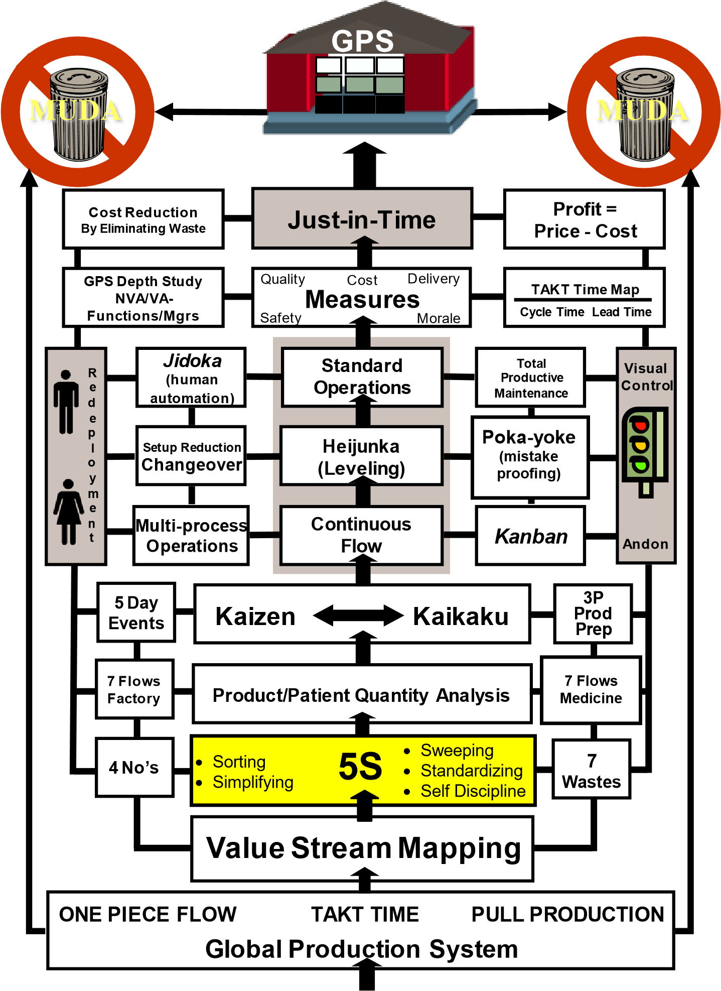
Committed Leaders

 | Develop a 5S Implementation Plan  Refer to 5S Work Standard for daily 5S Guide and Checklist
  5S Guide
  DEVELOP A PLAN
Steps | Notes
1. Identify 5S project | Purpose: To determine where the 5S opportunities are your area/dept and to work with area management and employees to gain consensus on the best project. Do this at least 6 weeks prior to a 5S event.
2. Start 5S Project form | Purpose: To document the 5S project, clarifying the current situation, boundaries, team members, and project theme. Have this document started two weeks prior to the 5S event.
3. Coordinate 5S week | Purpose: To plan the 5S event week and ensure participants have what they need, get training that will help them succeed, and have a plan for the 5S event week.
4. Communicate the plan | Purpose: To ensure the area knows there will be a 5S activity coming their way. This is a good opportunity to explain what 5S is and how it may affect them throughout the week. It is important that the area employees who are not involved in the project feel they understand what is happening and how they can be involved. Work with process owner to identify spot for 5S communication board and red tag area in one week prior to 5S event.
5. Coordinate and schedule services required from support organizations. | Purpose: To build collaborative relationships within and across areas/dept, and to help ensure a smooth implementation with no surprises.  - Consider cross-shift schedules.  - Acquaint yourself with procedures of support organizations.  - Establish a contact person in each support organization to let them know IN ADVANCE: – What you are doing.  - When.  - How they might be affected.  - What you need from them.  - Find out what the support organization needs from you.  - Examples of support organizations (including but not limited to):  - IT – Supplies  - Equipment rooms – Housekeeping  - Facilities
6. Communicate  your plan to upper management. | Purpose: To get buy-in and support from your sponsors, process owners, managers and other management stakeholders.  - Solicit feedback on their expectations and goals.  - Gain agreement among all parties.  - Send the initial 5S project form, explaining the project to the sponsors of the project.

Purpose  When |  | Perform Sorting Activity – Red Tag Technique  To assist work group in separating the necessary from the unnecessary items in the work area.  After pre-5S evaluation and scoring.
  5S Guide
  SORT
Steps |  | Notes
1. Understand the boundaries of this project; Pre-5S Score and identify a Red Tag Area |  | - Team understands the boundaries of the 5S Area Project.  - Team conducts a Pre-5S Evaluation Score and takes Pre-5S Pictures.  - Review criteria for tagging with the 5S team. Refer to table in step #2. Red tags go on items for potential removal. They provide a clear visual signal that the 5S team is considering the removal and an opportunity for area employees to give feedback.  - Create a 5S communication board for daily staff huddles and posting info to share across day and evening shifts.
2. Team members individually identify unnecessary items in the assigned work area.  Caution: Focus on dept-owned versus personal property. |  | • Every individual walks through assigned area and physically touches everything. As each item is touched, do the following:
  IF: | THEN:
  Item has a defined purpose and is used often enough to be considered necessary. | Do not flag.
  Item has no definite purpose OR is not needed. | Flag with Red flag.
  Item is determined unsafe and needed.  Item is unsafe and not needed. | Tag item to be repaired or replaced.  Red tag item to be removed from the work area.
  Unsure about item’s purpose. | Red tag item for discussion at Sorting Auction.
3. Remove all tagged items to designated holding area.
  IF: | AND: | THEN follow these steps:
  Single shift |  | Auction can immediately follow Tagging Activity according to your implementation plan.
  Single shift | Tagged item is too large to move. | Disposition of item during auction walk-through.
  Cross-shift |  | Hold tagged items 2 days prior to conducting auction/garage sale to other like dept./areas.  List all tagged items on 5S Red Tag form and post in communication area for staff to preview prior to auction.
  Cross-shift | Tagged item is too large to move. | Disposition of item during auction walk-through.
Purpose When | Sorting Activity – Conduct Sorting Auction/Garage Sale  To assist auctioneer in conducting Sorting Auction to dispose of tagged items.  Do this after all items have been sorted and red tagged.
  5S Guide
  SORT
Steps | Notes
1. Advertise the Auction /Garage  Sale | Determine which areas/depts may have a need for red tag items that have been set aside from 5S area.
2. Designate scribes to record on 5S Rag Tag Log | - Complete 5S Red Tag Action Log; record who claimed the item; what department and location they will place this item.  - If another dept claims a surplus item, note date; dept; contact person name and pick up/send date.
3. Hold up each item for auction. | One item is handled at a time.
4. Ask criteria questions for each item. | Examples:  - Who needs it?  - What is it used for?  - How often do you use it?  - How much of it do you need?  - Is it safe?
5. Dispose of each tagged item.
  IF item is: | AND: | THEN follow these steps:
  Claimed |  | Claimant determines a location for the item.  Scribe records action taken on the 5S Red Tag form. Items must be dispersed by the end of the week.
  Unclaimed | Is still usable | Record the unnecessary item on the 5S Red Tag form and place in appropriate container for removal.
  Unclaimed | Unusable by anyone | Discard immediately. No recording of the item is needed.
  Very large (file cabinet, storage cabinet, etc.) |  | Scribe records action needed on the Newspaper.  Conduct a walk-through of area disposition of large tagged items.

 | Sorting Activity – Final Steps to Complete Sorting
  5S Guide
  SORT
Steps | Notes
Print 5S Red Tag form with items | - Post 5S Red Tag form on 5S communication board.  - For the unclaimed red tag items– Post a note in the 5S Red Tag area, items must be claimed by the end of the week or will be discarded.  - Add as a Newspaper item - Red Tag Items to be removed from area and the date being by the end of the week.  - By the end of the week, with exceptions for complicated items, all should be removed by the date identified in the 5S Newspaper.
5S Guide  SIMPLIFY  Purpose When | Prepare for Simplifying  To create a place for everything and everything in its place.  Do this after all unnecessary items have been removed from the workplace.
Steps | Notes
1. Review Simplifying  Guidelines | Consider the following guidelines:  - Items used daily should be at point of use.  - Items used weekly should be close at hand.  - Overflow of frequently used items should be stored separately so that only the amount required is at the point of use.  - One is best; reduce number of duplicated items and storage locations whenever possible.  - Items used monthly, quarterly, annually should be stored on top shelves or in another storage area.  - Apply 45 degree rule, minimize twisting.  - Use strike zone rule - store items above the knees and below the chest.  - Store heavy items at waste level or on bottom shelves where ergonomic strategies can be applied.
2. Simplify necessary items | - Determine appropriate quantity of necessary items.  - Determine best placement for necessary items.  - Determine best place for frequently used items.  - Take a step back and ask the area staff to assess if the placement of items is clear and creates flow.
3. Identify Label Coordinator and  Labeler of Item | - Labeling is one of the most common techniques.  - Designate one person to make a list of the labels needed and one person to make the label:  - All appropriate items have visible labels.  - If required to order permanent labels, a list for ordering labels has been prepared and forwarded to label coordinator and/or process owner.  - Create an action item for the label order on 5S Newspaper – (who placed the order; identifying department/designated person that ordered the labels; and who is responsible to adhere labels upon arrival).

5S Guide  SIMPLIFY  Purpose When | Simplifying Activity - Labeling Technique  To assist work group in labeling all appropriate items in the workplace.  Do this after locations for all items have been designated according to their use.
Steps | Notes
1. Apply temporary labels to ALL items and locations deemed necessary. | work area (may not be appropriate in al Examples: Contents of…  - File cabinets – Files  - Drawers – Shelves  - Tools – Boxes | Use masking tape as temporary label to identify ALL items determined to be necessary for the l areas).  And…  - Garbage cans – Books – Chair  - Computers – Supplies – Cleaning supplies – Stationery
2. Mark each label. | Print legibly:  - The name of the item.  - The item number and vendor if • | not from stores.  The minimum/maximum number of items (only applicable to multiple items).
3. Identify items that require restocking. | Record on label when item should be ordered (by date or by item count).
4. If organization requires permanent labels need to be ordered. | - On a piece of paper record the label exactly as it should read.  - For any reorder or new supplies determined to be necessary, one 5S team member will contact the appropriate person in regard to what is needed. Note: If your organization does not have a designated person than the team member should consult with the Area Manager.  - If labels need to be ordered or created by another department then add this action to the 5S Newspaper.
5S Guide  SIMPLIFY  Purpose When | Simplifying Activity - Outlining Technique  To assist work group in outlining all appropriate items/areas in the workplace.  Do this after locations for all items have been designated according to their use.
Steps | Notes
1. Identify and agree on the items or areas that require outlining. | Examples: (May not be appropriate in all areas)  - External work area boundaries  - Movable carts  - Positioning of overhead projectors on tables  - Location of garbage cans

- Walkways
- Stationary items in cabinets
- Designated receiving area
2. Outline the items or areas identified. | - Use masking tape for outlining.  - If using floor tape, agree on a standard.
3. Label each item or outlined area. | - Legibly print the name of the outlined item or area directly on the tape.  - Mistake Proof by posting a picture of the item(s) on the wall directly in this designated area.
5S Guide SIMPLIFY  Purpose  When | Simplifying Activity – Shadow Board Technique  To assist work group in making a shadow board for organizing supplies/tools in the workplace.  Do this after locations for all items have been designated according to their use.
Steps | Notes
1. Identify what supplies/ tools require a shadow board. | Examples: (May not be appropriate in all areas.)  - Small hand tools  - Copier supplies  - Desk supplies
2. Have team draft on paper shadow board design. | Include in your design:  - An paper and pencil outline of the order supplies/ tools will be placed on this shadow board.  - The layout should group items by type and items connected to one another (i.e. drill and bits).  - Location of this shadow board.  - Leave “draft design” posted for 1-2 days for viewing by all shifts (draft shadow board outline should be done in permanent marker and make sure you keep a copy in case someone throws it away).  - Have a feedback form posted next to the shadow board or provide contact person name, phone number and email address as another option to receive employee feedback on the 5S Team’s mockup.
3. Label each outlined item and its location with its name. | - When layout finalized outline with item with tape.  - Use a label machine create a label with legal item name and place in middle of outlined item.

Purpose When | Perform Sweeping  To assist work group in developing daily Visual and Physical Sweeping activities to assess and maintain the work area.  Do this after the Simplifying activities have been completed in your area(s).
  5S Guide
  SWEEP
Steps | Notes
1. Prepare a list of  VISUAL Sweeping  activities to occur in the work area. | - Take a final look of the area to ensure everything has a designated place and everything is in the correct place.  - Create a list that shows what to do, frequency and responsibility for individual to audit common areas.  - Actions should support Visual Sweeping of work area: items are in their place, labels are present, outlining and labels in place, shadow board is in place, etc.  - Examples of what to check:  - Items are orderly and safe – Equipment is in designated location  - Supplies/tools are in designated locations – Supplies/tools are in stock  - Create a visual sweeping list (5S audit tool, visual workplace reminders) that rotates staff/responsibilities for auditing the area(s).  - Coordinate with others as appropriate to look at area with “fresh eyes.”
2. Prepare a list of  PHYSICAL Sweeping  activities to occur in the work area. | - List shows frequency and responsibility for individual and common areas.  - Actions should support an audit of the work area to physically clean and maintain the work environment.  Examples:  - Dust cabinets – Clean computer – Empty hole punch  - Clean equipment/tools – Empty recycling box – Clean trash can  - Sweep floor
Purpose When | Perform Standardizing Activity  To assist work group in documenting agreements made during 5S activities; develop standard work to ensure consistency and to develop a plan for periodic rotation through 5S activities. Do this after Sweeping Activities.
  5S Guide
  STANDARDIZE
Steps | Notes
1. Review and document Sorting and Simplifying activity. | - Document on a work standard form “What criteria did we establish for sorting?”  - Ask, “Are the criteria acceptable?”  - Draw a map or make a list of what items are placed where on each shelf and in each area.
  IF: | THEN follow these steps:
  Yes | Do nothing – no change required.
  No | Document changes in criteria.  Place agreement in 5S file.
2. Review and document Simplifying activity. | Do the following:  - Examples to consider:  - “Is there an area designated as “holding or assessment time to determine if used?”  - “Do we red tag items and hold in area until auction?”  - “Do we choose a monthly clean out day to look for items not used or expired items?” – “Do we want do identify par levels or maximum order quantities?”  - Document on a work standard form and multi-skills form, the training plan to get appropriate staff and new staff trained and post on 5S Wall or Visibility Wall.  - Document agreements and standard work and determine training plan to get appropriate staff trained including, but not limited to) those made for:  - Labeling  - Outlining  - Shadow boards  - Storage and stock quantities of supplies and tools  - Safety

 | Perform Standardizing Activity  (continued)
  5S Guide
  STANDARDIZE
Steps | Notes
3. Review and file Sweeping activity lists. | Do the following:  - Obtain Visual and Physical Sweeping lists.  - Ask, “Are the activity lists rigorous enough to maintain a safe and clean work area?”
  IF: | THEN follow these steps:
  Yes | Do nothing – no change required.
  No | Ask, “What improvements are needed?” Document changes in criteria.  Place agreement in 5S file.
4. Establish a schedule for rotation through 5S activities in work area. | • Document agreed-upon sweeping schedule on note paper (see attached example). • Post in 5S communication area.
Purpose When | Perform Self-Discipline - A Team Activity  To assist work group in following through on all 5S agreements made for the work area.  1-2 weeks after Standardizing Activity has been completed in your dept/area, and on a regular basis thereafter.
  5S Guide
  SELF-
  DISCIPLINE
Steps | Notes
1. Determine if the 5S agreements are being followed in the work area. | • Ask, “Are we following the agreements we put in place as a result of our 5S activities?”
  IF: | THEN follow these steps:
  Yes | Acknowledge and congratulate.
  No | List those agreements not being followed.  Ask “Why not?”  Ask: “How can we fix it?”  Document agreed-upon solutions.  Place agreements in 5S file.

2. Develop a plan to address needed improvements. | - Be specific.  - Identify responsibilities.  - Record on the Newspaper.  - Post in communication area.
3. Review Individual Self-Discipline 5S Implementation Plan. | - Point out its location.  - Review purpose.
4. Check your work. | The result will be a team identification of which 5S agreements are and are not being followed through. You will know you have addressed SELF DISCIPLINE tasks when:  - A group assessment has been performed on compliance with Standard Work; audit schedule and tool; and follow up on action items identified from audit  - A written plan has been prepared detailing issues that need to be addressed and an action plan developed.  - Updates and additions have been made to the Audit Schedule and Tool; Audit and Standard Work.  - Any action items have been added to the Newspaper.  - Achieve a Level 5 when you have maintained a Level 4 consistently for one (1) year.
Purpose When | Perform Self-Discipline - Individual Activity  To assist individuals in applying 5S agreements to personal work area.  Do this after Standardizing Activity has been completed in your area.
  5S Guide
  SELF-
  DISCIPLINE
Steps | Notes
1. Go to your area. | • The immediate area where you perform most of your daily activities, i.e., cubicle, bench, etc.
2. Determine the effectiveness of your individual organizing methods in support  of the 5S agreements. | Considering your own personal work style, ask yourself:  - “Am I following the guidelines put in place as a result of 5S efforts?”  - “Is my work area safe?”  - “Is it neat and organized?”  - Notebooks neatly stacked and labeled?  - In basket cleaned daily?  - Posted items neat and organized on wall?  - Method for planning/prioritizing work assignments?  - Routine use of proper tools and methods?  - Daily schedule posted?  - Use of in-out boards in the area?  - Method for responding to phone messages?

• Respond to the following:

IF: | THEN:
You are following 5S agreements. | Ask, “How will I maintain and improve?”
You are not following 5S agreements. | Ask, “What steps can I take to improve?”

3. Prepare a personal 5S plan. | - This is your own personal plan.  - Be realistic as you decide what improvements you want to make. • Revisit this plan frequently and make adjustments accordingly.
4. Check your work. | The result will be a personal 5S plan. You will know you have completed your own SELF DISCIPLINE task when:  - A self-assessment has been performed on compliance with Standard Work.  - You have prepared a written plan to improve your area using 5S methods and tools. • You have maintained a Level 4 consistently for one (1) year.
5S Report Out Work  Standard | 5S Final Report Out  The purpose of the Final Report Out is to present the actual results obtained during the week to staff, define the action plan required to close out the 5S newspaper items that were not completed during the week, and highlight the 5S audit process to hold the gains.  - TAKT time for the final report is 20minutes per team – rehearse your presentation  - Present Standard Work Combination Sheet – identify the order for ALL team members to report – NO EXCEPTIONS – everyone on the team has a role)  - Present Team Photo followed by the 5S Project Form  - Present the pre 5S Evaluation Score  - Present pre 5S Target Sheet and data that would be applicable (space used, restock cycle time, missing items, time spent looking for items, etc)  - Present 5S Zone Map  - Present (5) 5S Idea Sheets to show the type of waste (7 types) you encountered - order as follows: pre 5S photo, ideas sheet, post 5S photo (note: ideas sheets to show newspaper item number – write as NP#1)  - Present data and documents (Spaghetti Chart; Standard Work; Multi-Skills Training Form, interesting finds, picture of communication board used for daily huddle)  - 5S Report Out must include 5S audit process standard work and audit tool  - Present Red Tag Action Log  - Present Post 5S Evaluation Score  - Present the Newspaper, and highlight any open items  - Present Final 5S Target Sheet  - Present the 5S Results Form & Lessons Learned  - Present Thank You list to acknowledge people in the area who assisted with the 5S project

Example of a Team Agreement for 5S

Department/Area

5S Event Date

Area Manager

5S is a strategy for organizing the workplace to minimize waste of time. Having everything clean, neat, and in the proper location enhances quality and productivity because it helps make things easier to find and problems more visible.

Our team has agreed to implement a standard work process for 5S:
Date | Signature

Sort | Separate necessary from unnecessary
Simplify | Create a place for everything
Sweep | Control the work area visually and physically – perform a sweep
Standardize | Document agreements made during previous 5S steps to organize the workplace
Self-Discipline | Follow through on all 5S agreements and 5S audit standard work

As part of this implementation plan our team agrees to read and sign the agreement below:

- We agree to be responsible for leaving our area neat, clean and organized on a daily basis at the end of shift (e.g. desks and workspace area used during the day)
- We agree to participate in the weekly 5S Audit and record findings and actions taken
- We agree to act as audit lead for a one month rotation
- We agree to hold staff huddles to share 5S audit results and generate new ideas for improving our workplace (sign up for 5S audit responsibility on a monthly rotation basis)
- We agree to monitor and provide feedback on inventory and supply management

For 5S Audit, have team member’s sign up for a one month rotation as audit lead. Post 5S audit standard work, multi-skills training form, and audit tool in workplace. Use 5S communication board for staff huddles to share and discuss audit results. As part of audit, visual and physical sweep of the work area is performed.

Team Member: Audit Month:

5S Weekly Audit Tool - Please mark with a ✓ or ✗

Date
1. No additional or excess supplies found in area

2. No additional items in personal area(s)

3. Every item is in a designated spot and labelled and/or outlined (tools, equipment, supplies)
4. 5S Communication board is up to date and organized

5. Work area appears clean/ organized and everything in its place
6. Personal area is clean and organized
Initials of audit lead

Please initial when audits are complete Checks to be done 1x/week every Wednesday - Should take 8 minutes to audit, follow standard work

Areas for Improvement
What is working well? What do you need to bring to your supervisor/manager’s attention? What ideas do you have to improve 5S?

5S Red Tag Action Log
5S Project Date: |  |  | Area/Dept:
Item # | Item Description  (Record SKU #, source and min/max level) | Quantity | Reason for Red Tag  (garbage, storage, relocate, surplus) | Action Required and Date | Estimated Value ($) | Cost Implication (for Finance Only)

Total Cost:

